The Moodle2Word format lets you create Multiple Choice, Multiple Answer, True/False, Matching, Short Answer, All-or-Nothing Multiple Choice, Essay and Select Missing Word questions types using a simple, human-readable format that you can save word document (.docx) file and import into a Moodle.

STEP 1: Download the template
Download moodle2WordInstaller_v3_4wd.docm and moodleQuestion.dotx files from LASU CBT COURSES EXAMINATION TEMPLATE https://lasu.edu.ng/cbt_format/

STEP 2: Install the template
- Double-Click on moodle2WordInstaller_v3_4wd.docm file to open and install the template.
- The page loads and you get a security warning as shown in the image below
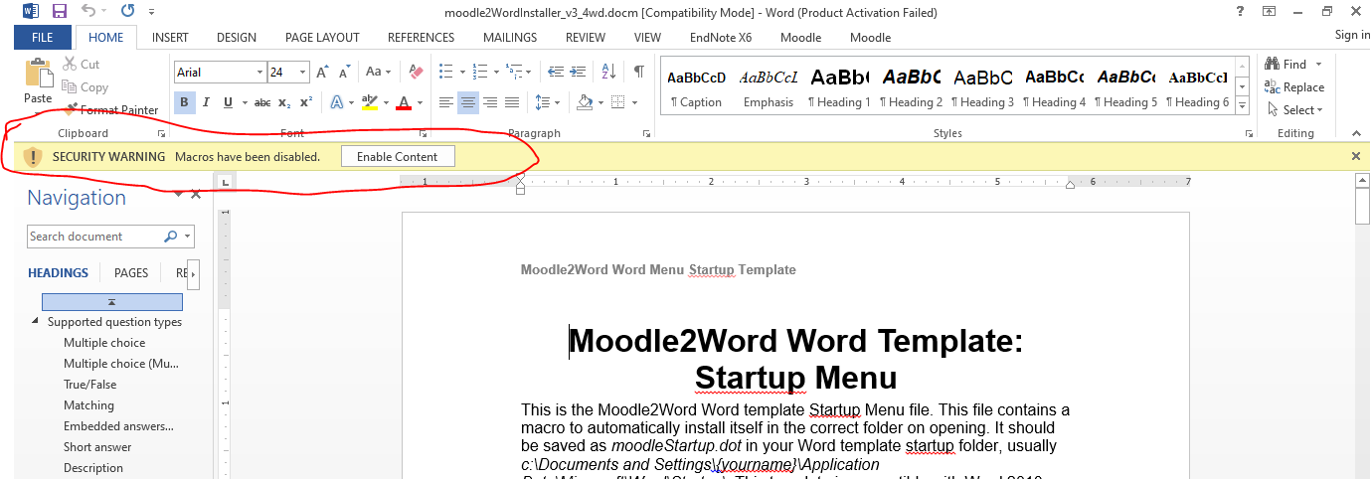
- Click on the Enable Content button to allow the macro embedded in the template to run.
- Once the macro is enabled, a dialog requesting the user to install the template is displayed as shown in the image below
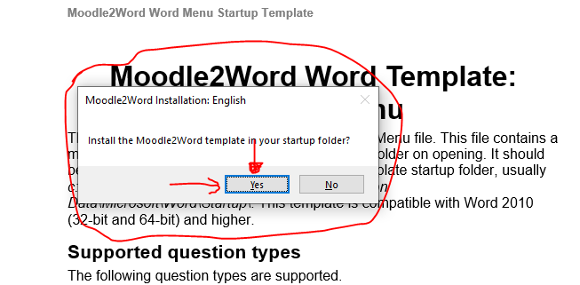
- Click on the yes button to allow the installation
- Follow any further instruction(s)
- Restart your Microsoft Word application

STEP 3: Start setting your questions
- Launch Microsoft word

- If the template is properly installed, a Moodle tab menu added to the menu bar will be displayed

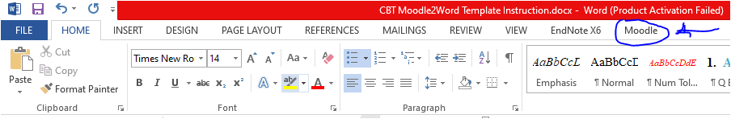

- Click on the Moodle menu tab at the top

- Under the File/Category Management sub-menu, click on the New Question File menu

- A Save As File Dialog is displayed
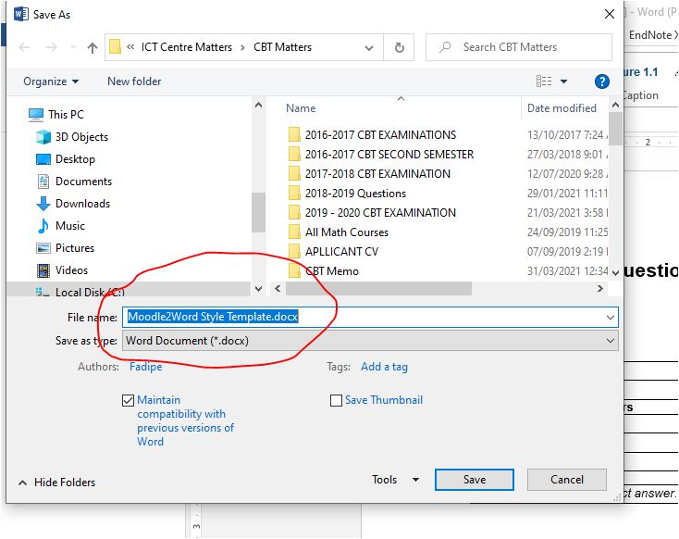

- Change the default name to reflect the name of the file (course)
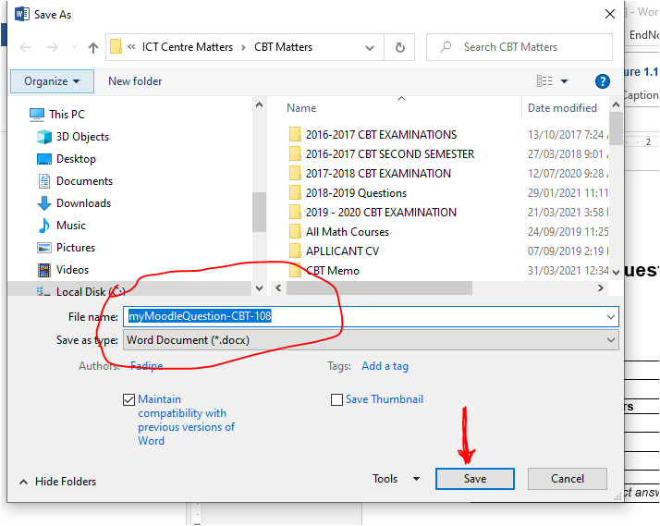

- Click on the Save button to save the file

- A file with the same name as typed in the dialog box is displayed and ready for use

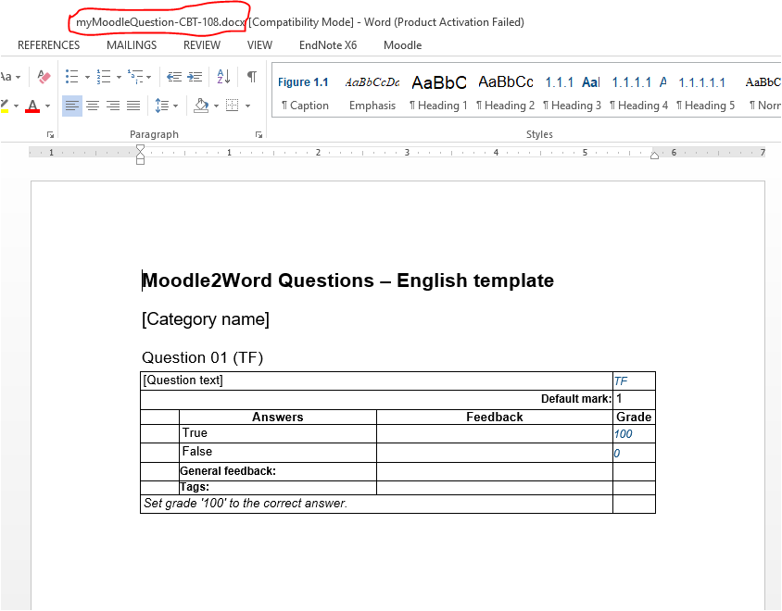

- To design a question, type your question in the [Question Text] row provided in the table; and type 100 in the Grade Column as the value corresponding to the right choice in the intersection box between the Answer Column and the Grade Column

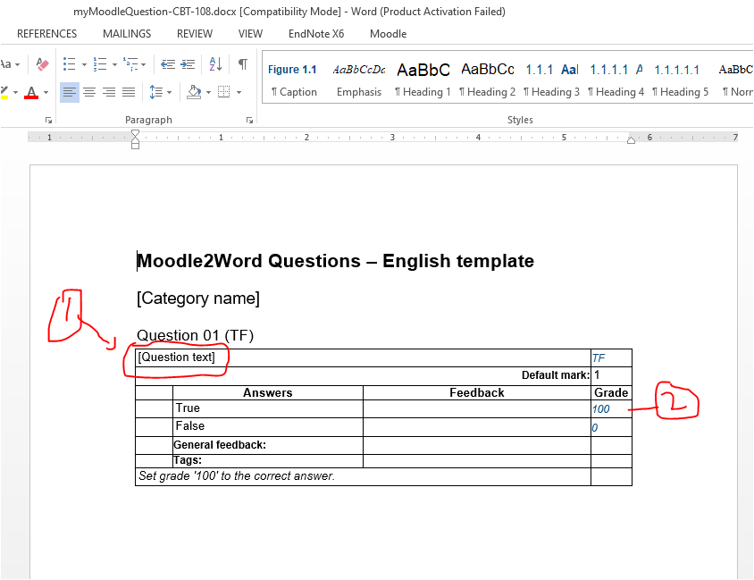

- To start a new question
  - Click on the Moodle Menu tab

  - Under the Add Question sub-menu, click on the question type choice

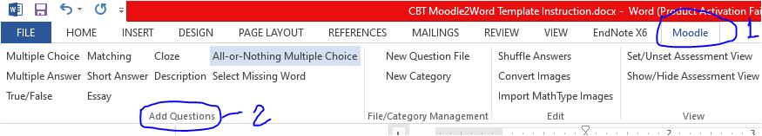
  - For Multiple Choice question type, click on the Multiple Choice question button

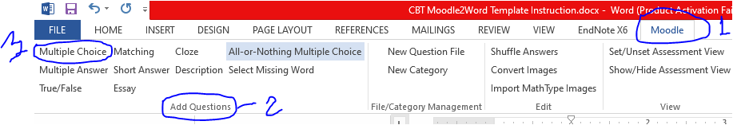

  - The question template corresponding to the question type i.e. multiple choice is displayed
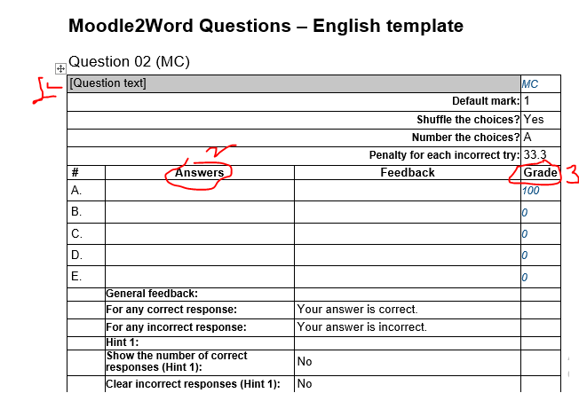

  - Type in your question in the box provided (1)

  - Type in your choices in the boxes provided under the Answers Column (2)

  - Type in the corresponding grades (either 100 or 0) in the Grade Column (3)

  - Repeat Step I – VII for subsequent questions

Download and View tutorial videos on LASU site for further instructions.

